|  |
| --- |
|  |

Purebred Golden

<https://unsplash.com/search/photos/dogs>

Photo by [Robert Koorenny](https://unsplash.com/@fujicanon?utm_source=unsplash&utm_medium=referral&utm_content=creditCopyText) on [Unsplash](https://unsplash.com/search/photos/dogs?utm_source=unsplash&utm_medium=referral&utm_content=creditCopyText)

Purebred Pugs

Photo by [Sneaky Elbow](https://unsplash.com/@sneakyelbow?utm_source=unsplash&utm_medium=referral&utm_content=creditCopyText) on [Unsplash](https://unsplash.com/search/photos/dogs?utm_source=unsplash&utm_medium=referral&utm_content=creditCopyText)

<https://unsplash.com/search/photos/dogs>

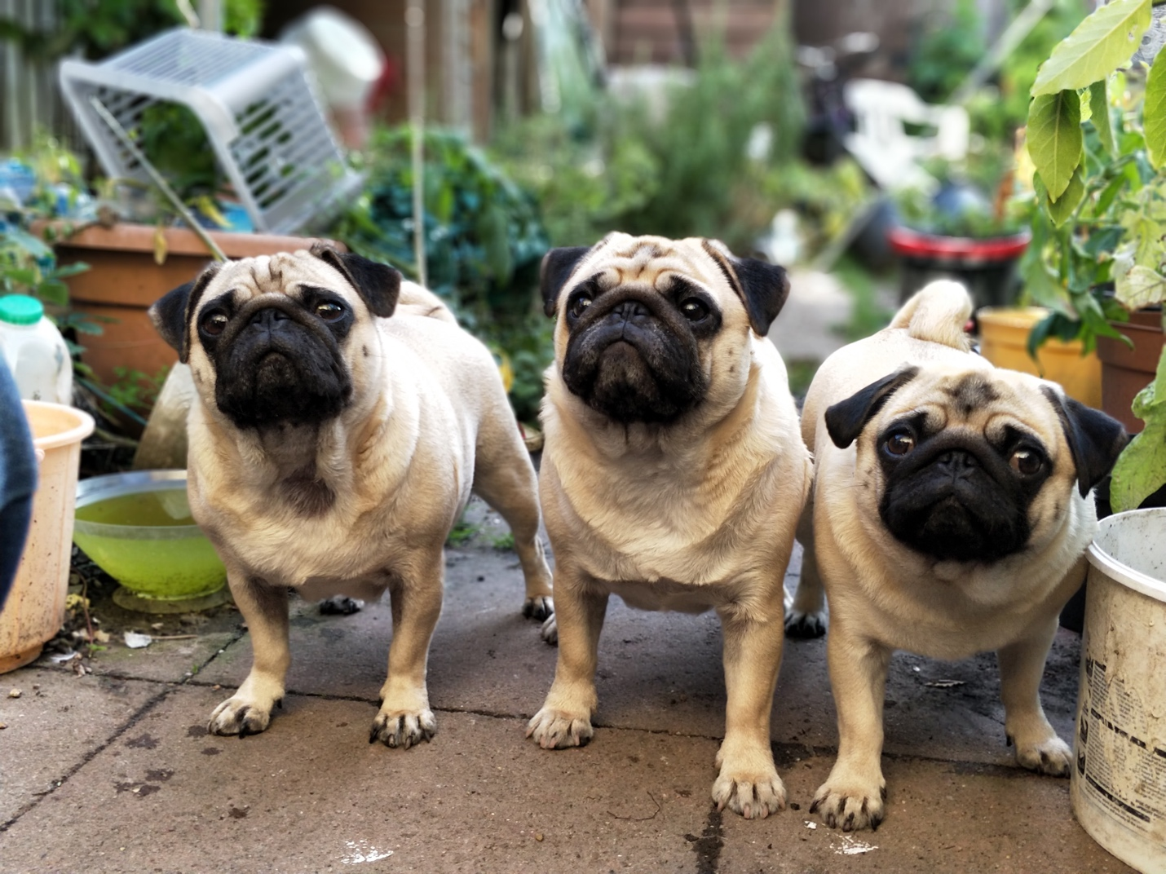

Personal Photos

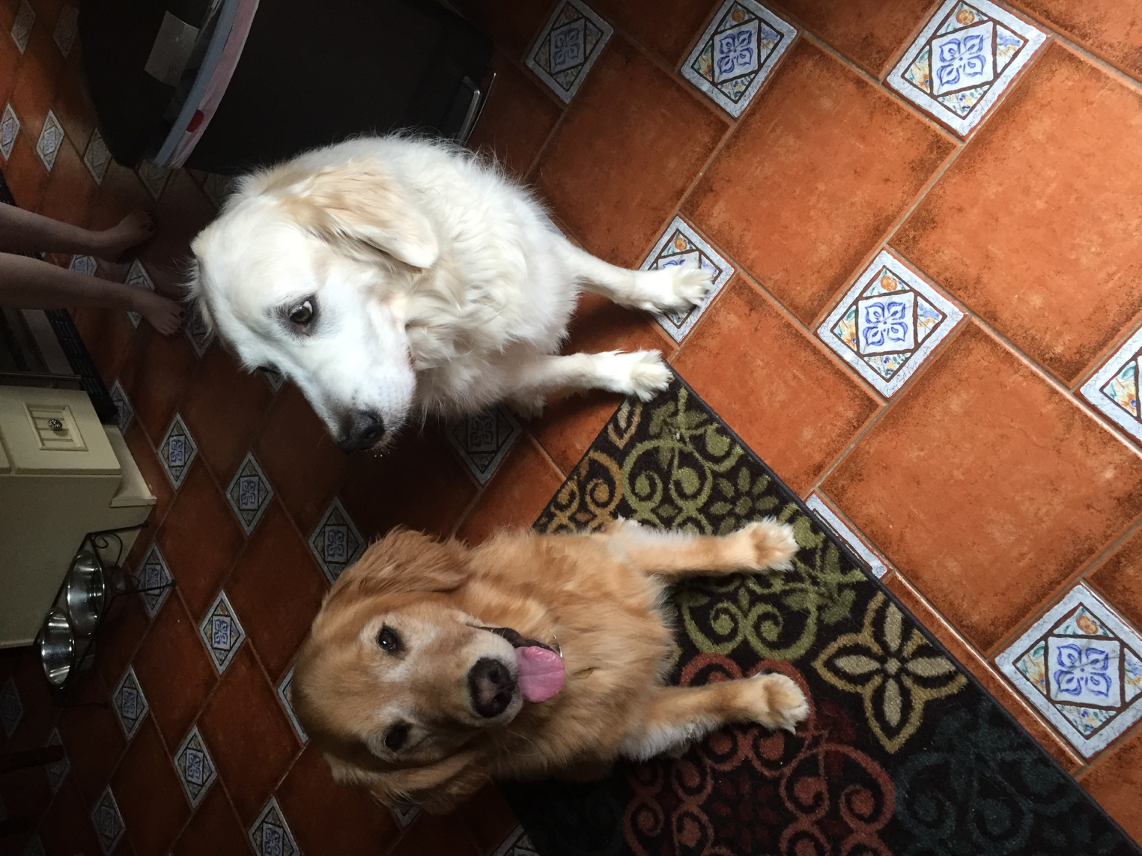Simba and Jersey

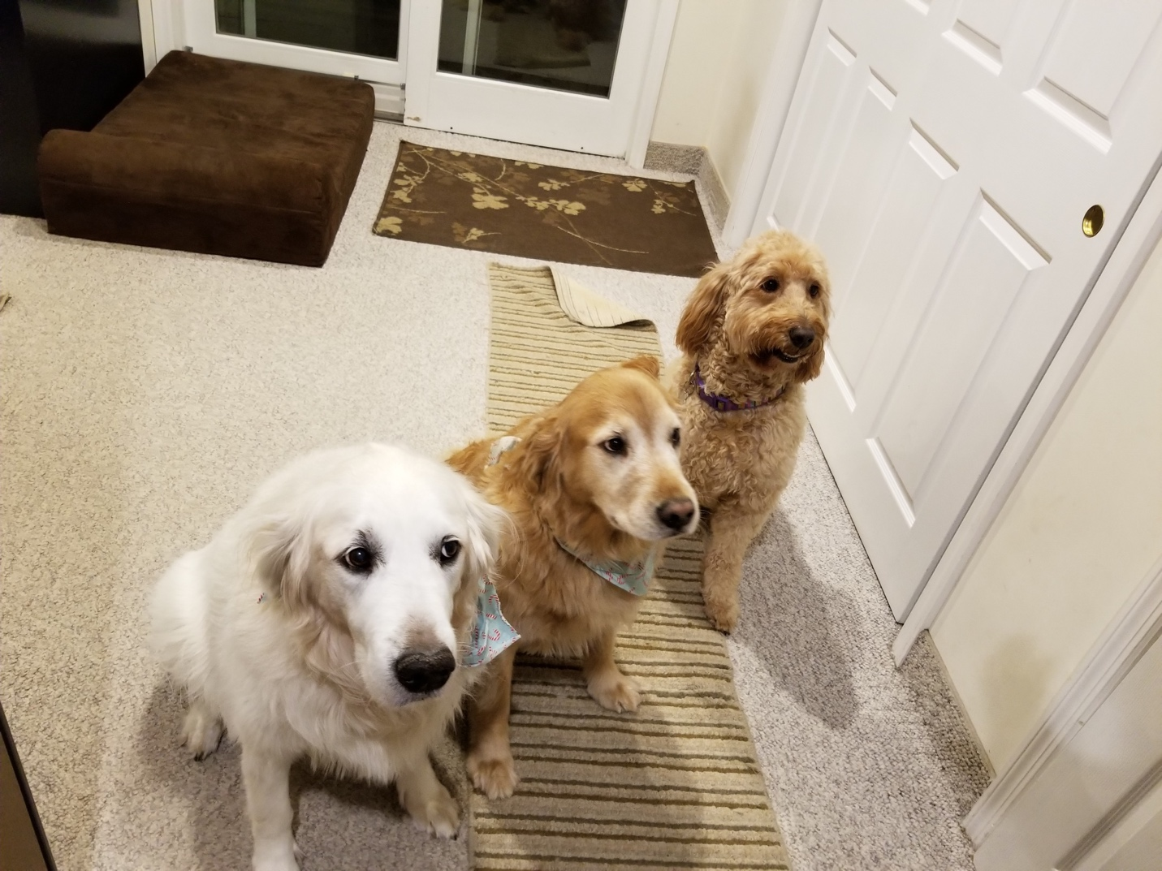

Simba, Jersey and Kori

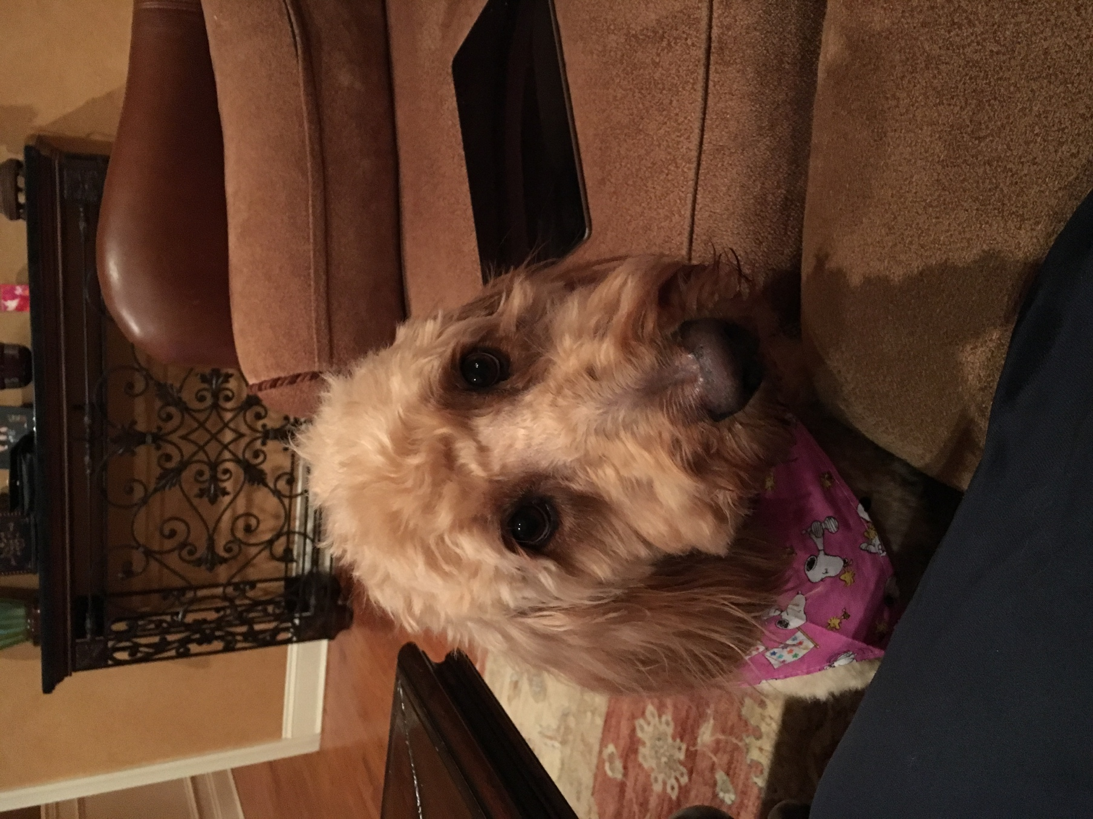

Kori Headshot

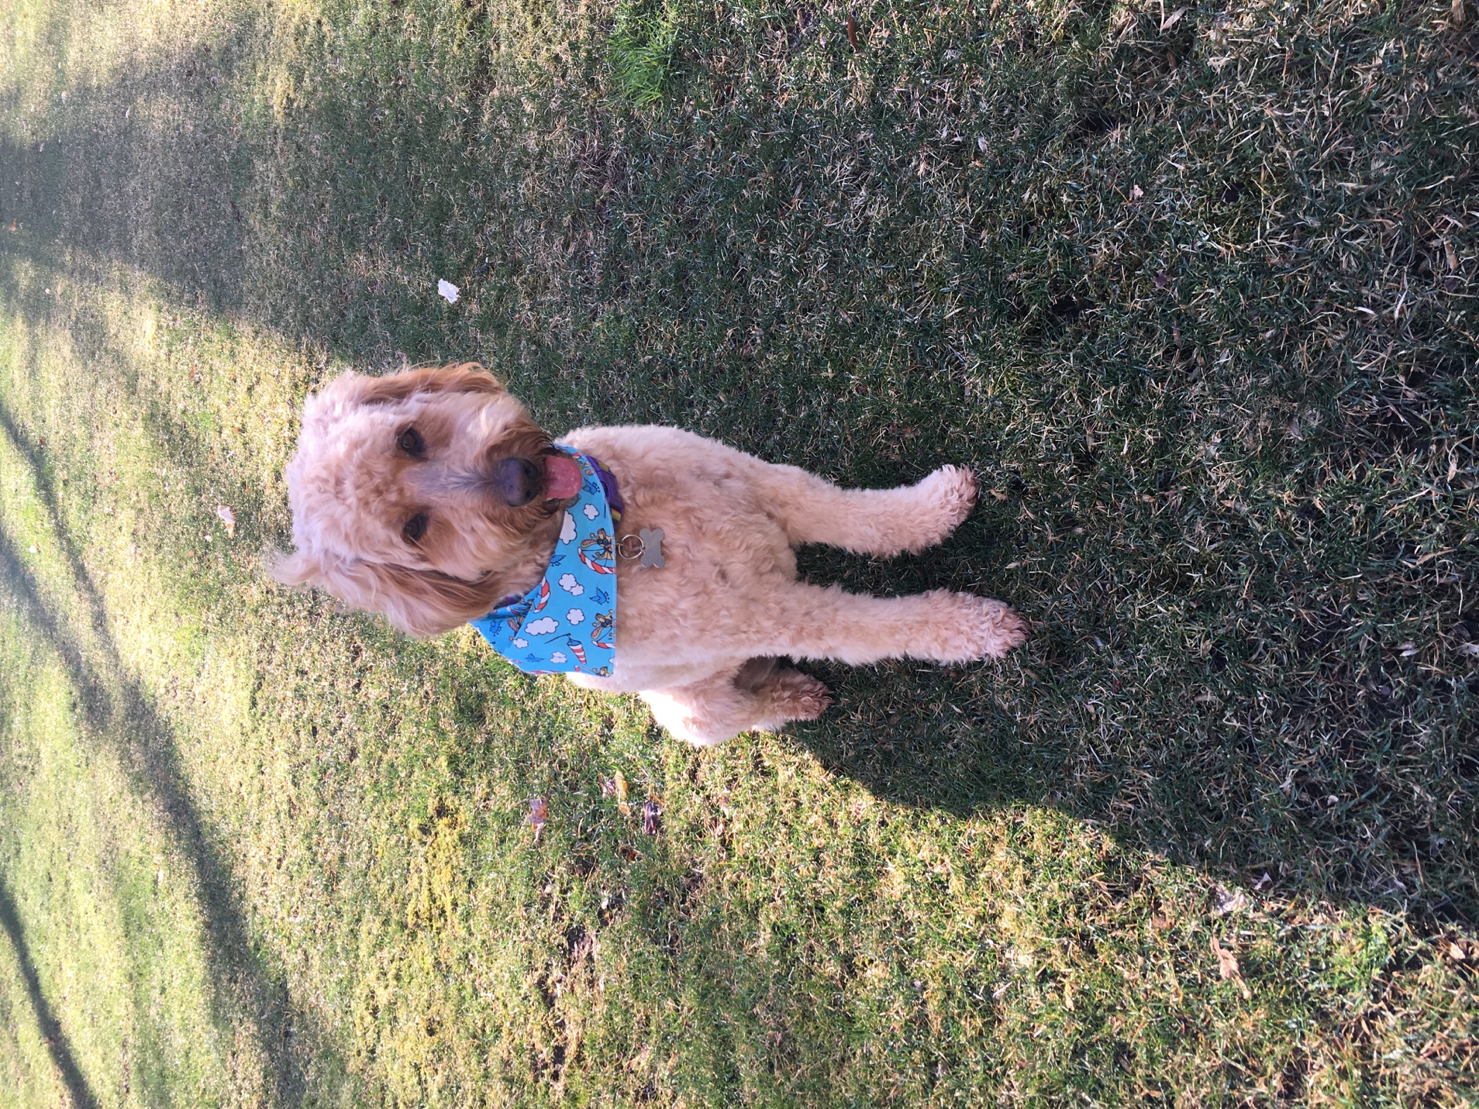

Kori Smile

Video:

Which type of dog is right for you?

<https://youtu.be/dC3H8YN-460>

<iframe width="560" height="315" src="https://www.youtube.com/embed/dC3H8YN-460" frameborder="0" allow="accelerometer; autoplay; encrypted-media; gyroscope; picture-in-picture" allowfullscreen></iframe>

What is a mut?

<https://youtu.be/oSr1kyPBoZ8>

<iframe width="560" height="315" src="https://www.youtube.com/embed/oSr1kyPBoZ8" frameborder="0" allow="accelerometer; autoplay; encrypted-media; gyroscope; picture-in-picture" allowfullscreen></iframe>

**Images**

|  |  |  |  |
| --- | --- | --- | --- |
| **Name** | **Source** | **Owner** | **Usage** |
| Purebred golden | <https://unsplash.com/search/photos/dogs> | [Robert Koorenny](https://unsplash.com/@fujicanon?utm_source=unsplash&utm_medium=referral&utm_content=creditCopyText) | yes |
| Purebred pug | <https://unsplash.com/search/photos/dogs> | Sneaky Elbow | yes |
| Simba and Jersey | Personal | Phoebe | Yes |
| Simba, Jersey and Kori | Personal | Phoebe | yes |
| Kori headshot | Personal | Phoebe | Yes |
| Kori Smile | Personal | Phoebe | yes |
| Which type of dog is right for you? | <https://youtu.be/dC3H8YN-460> | Animal Planet | Yes for educational purposes |
| What is a mut? | <https://youtu.be/oSr1kyPBoZ8> | Animal Planet | Yes for educational purposes |